AL SHIRAWI ENTERPRISES

Ref.:Attach/DXB/232712-01 Date : 27 December 2023

QUOTATION

To: M/S
XXX.

Kind Attention:

With reference to your inquiry for Sweeper Attachment suitable for Backhoe Loaders Please find our offer as below
Sl # | Description | Qty | Unit Price AED | Extn’d.Price-AED
01 | Hook-On Sweeper Attachment  Specifications:-  Sweeping Width – 2.13M (7 feet)  Bucket Capacity – 1 Cu.m  Weight- 272 Kgs (600lbs)  Mounting Type – Hook and Locking Pin  Brush Drive:- Hydraulic Motor  Hydraulic Flow Required – 35 LPM to 76 LPM  Recommended Operating Speed 4 MPH  Overall Dimensions:-  Width 2230mm (94 inches) Length 880mm (34.5 inches)  Brushes 110550/60  You Tube Link:-  https://youtu.be/B4cMc5Y27FY | 01 | 25,000 | 25,000
 | VAT 5% |  |  | 1250
 | Total |  |  | 26,250

Terms and Conditions:

Validity : 30 days from Date of Quote.
Delivery : Ex-Stock
Warranty : 6 months or 1000 hrs whichever earlier, from Date of Delivery.
Payment : LPO

We hope the above-mentioned offer meets your requirement. Please feel free to contact us for any clarification.

We look forward to your valued order.

Azam Shiekh
Product Support Engineer
Mobile-050 459 7502

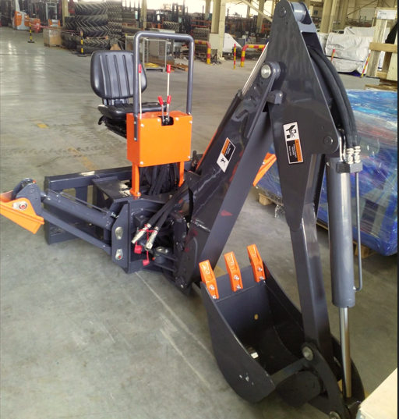
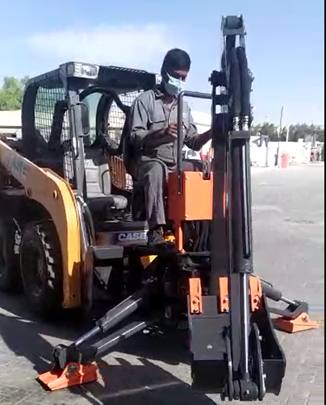

Video available in the below link

https://oattachments.com/product/backhoe-attachment-oattachments/

