


AL SHIRAWI ENTERPRISES LLC
Tax Registration Number: 100060237300003

QUOTATION
Ref.:DXB/Attach/260403-02 Date: 04 Mar 2026

To: M/S XXXXXXXXX

Attn: Mr. XXXXXXX- XXXXXX Manager,

With reference to your inquiry for Crusher Bucket, please find our offer as below

Sr No | Description | Qty | Unit Price AED | Extn’d.Price-AED
1.1 | CRUSHER BUCKET Model: NOACBA200A  Suitable for 20-ton class excavator  Brand- Oattachments Country of Origin-Korea  Hydraulic Flow (L/min): 150 -220 Opening Dimensions 930*460mm Suggested Material hardness:  Material compressive strength should be less than 50Mpa Weight (Kg): 3150 | 1 | 127,000.00 | 127,000.00
Net Order Value |  |  |  | 127,000.00
VAT Amount |  |  |  | 6,350.00
Net Order Value (Incl VAT) |  |  |  | 133,350.00

Terms and Condition
Validity : 30 days from Date of Quote.
Delivery : 6 TO 8 Weeks
Warranty : 6 Months against manufacturing defect, from Date of Delivery. Payment : PDC 90 Days, Subject to approval.
We hope above mentioned offer meets your requirement. Please feel free to contact us if you need any further clarification in this regard or should you need any kind of attachments. We look forward to your valued order.

Azam Shaikh
Product Support Engineer – After Sales Al Shirawi Enterprises L.L.C
P.O.Box 7427,Dubai, UA.E Mobile +971 50 459 7502
Mail: azam.shaikh@alshirawi.ae

https://oattachments.com/


Page 1 of 5

O.attachments

Quality Attachments for Construction & Agriculture Equipment.
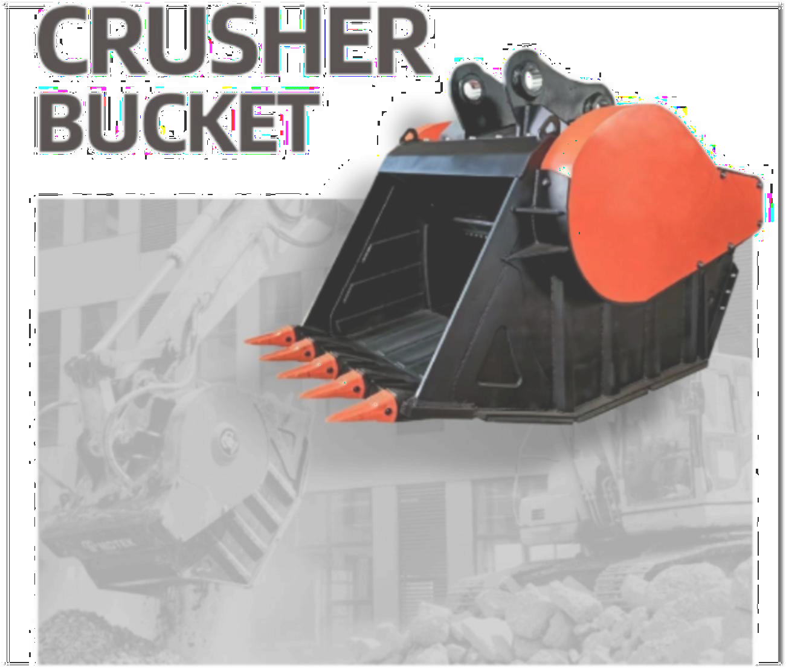

AL SHIRAWI ENTERPRISES (L.L.C.)
P.O. Box 7427 Dubai, United Arab Emirates
© OAttachments.com
Disclaimer: Pictures of products of different manufacturers with their product name, logo used for illustration purpose only.

Page 2 of 5

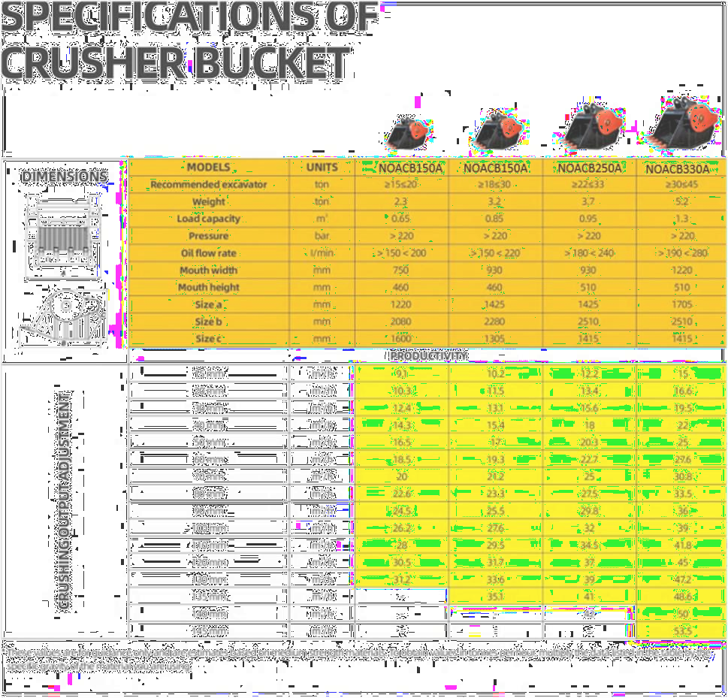


Page 3 of 5



Page 4 of 5

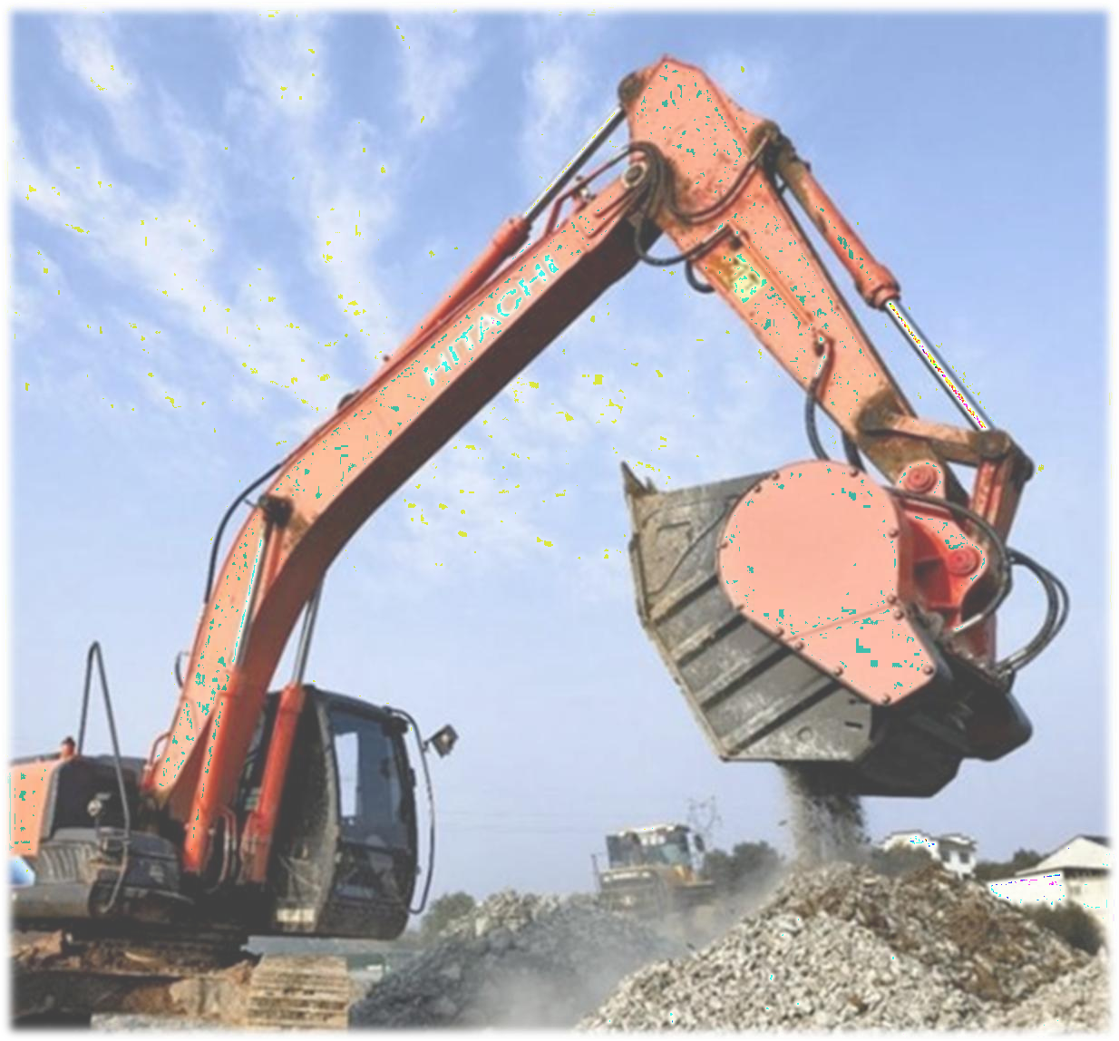

Page 5 of 5

