Ref.:Attach/DXB/262702-04 Date : 27 Feb 26

QUOTATION

To: M/S XXXXXXXX

Attention:- Mr.XXXXXXXX

With reference to your inquiry for Rear PTO driven Stone Picker Attachment suitable for tractors
Please find below our offer
Sl # | Description | Qty | Unit Price AED | Extn’d.Price-AED
01 | Rear PTO Shaft Drive Stone Picker Attachment.  Make-Oattachments, Korea  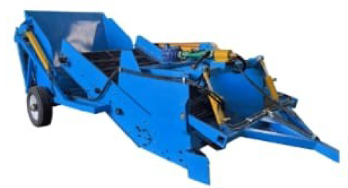  Specifications:-  Stone Size - Min 40 mm; Max-450 mm  Working Width-1500 mm  Working Depth- 100- 450 mm  Stone Picking Device Type- Digging Point Shovel  Stone Conveying Device- Grid Screen Conveyor  Stone Separation Device – Grid Screen(Screen Gap-30 mm)  Stone Unloading Type – Hydraulic Cylinder  Stone Unloading Height -1700 mm  Stone Collection Box Volume- 2.5 Cu.m  Weight – 2200 kg  Total Width – 1800 mm  Productivity- 2700 Sq.m/hour  Suitable Tractor- 90 HP and above | 01 | 68,400.00 | 68,400.00
 | VAT 5% |  |  | 3,420.00
 | Total |  |  | 71,820.00

Terms and Conditions:

Validity : 30 days from Date of Quote.
Delivery : 4 to 6 weeks
Warranty : 6 months or 1000 hrs whichever earlier, from Date of Delivery.
Payment : LPO

Please revert for any clarification.

We look forward to your valued order.

Vipin Viswanathan

Al Shirawi Enterprises LLC
050-394 0763

